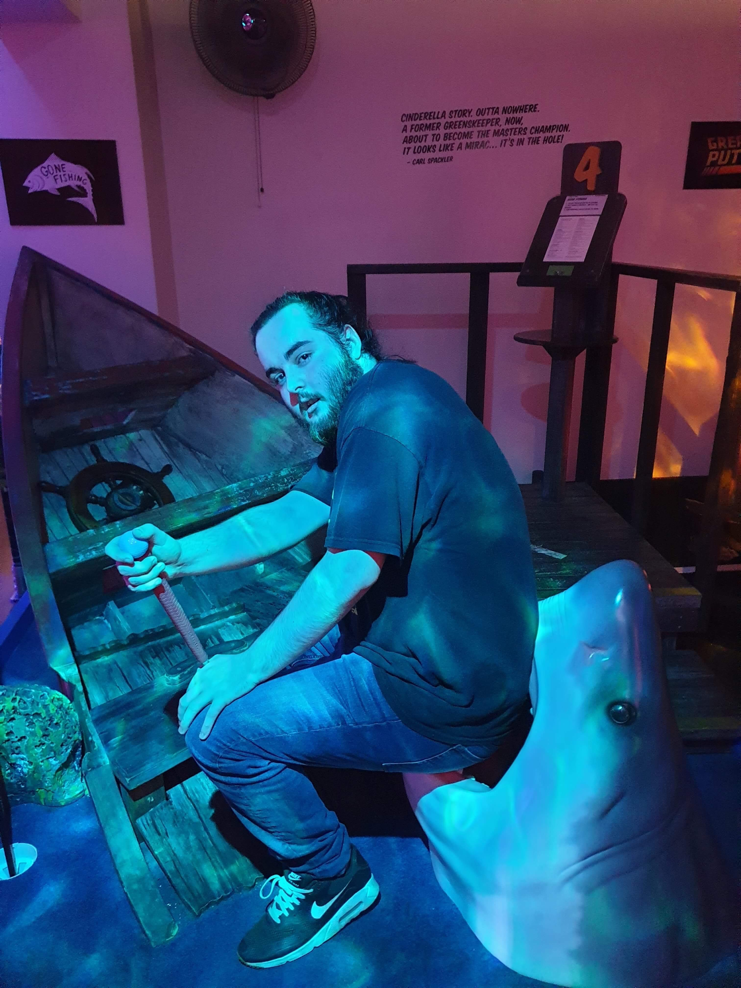
Luke Kavanagh - s3894758
email - S3894758@student.rmit.edu.au
Born in Dublin, Ireland 29/11/1999
Now resides in Perth WA
1831 R.IO 7/10M as of 11/03/21
I quite enjoy playing video games such as Hearthstone, WoW and other games along the lines or mobas’ FPSs’ and strategy games

Interest in IT
I really enjoy problem solving and technology so IT was a no brainer when nursing didn’t pan out. I would have to say my interest in IT started around the time my brother got his first PC back in 2006 I fell in love with video games and Technology in general. I don’t have much in the way of experience when it comes to IT. I chose to attend RMIT because a friend of mine suggested that I do my course via oua. I hope to learn the valuable skills to go forward and complete my bachelors of IT.

Ideal Job
https://www.seek.com.au/job/51785234?type=standard#searchRequestToken=953d3f34-6be5-4652-9d41-2a75fed4e07e
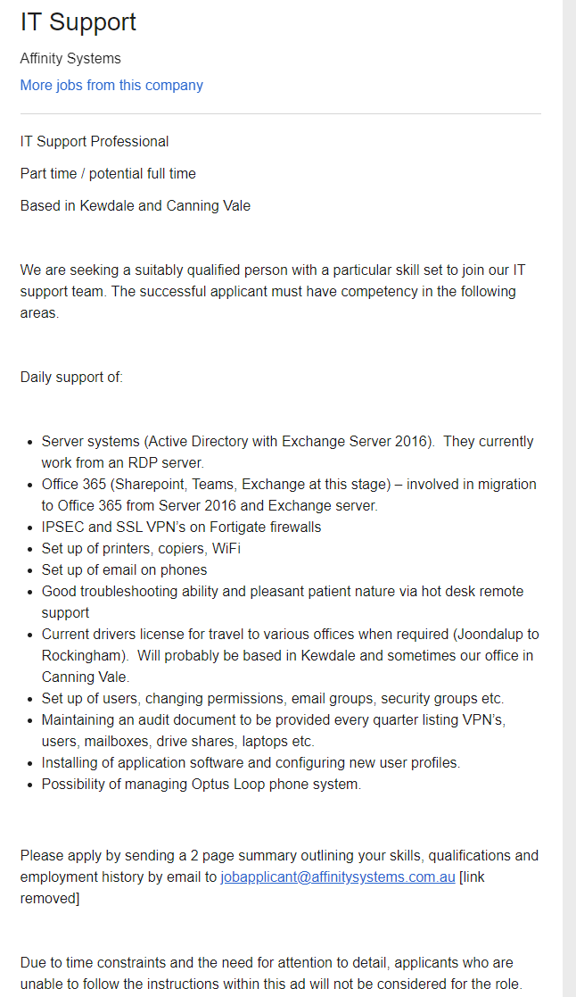This is your average run of the mill IT position the reason that I want to do this for my job is because it is pretty easy in what I will have to do. They require customer service experience, Experience in the IT sector, Drivers licence and skill in the English language